**Class:** Final Year (Computer Science and Engineering)

**Year:** 2022-23 **Semester:** 1

**Course:** High Performance Computing Lab

**Practical No. 11**

**Exam Seat No :** 2019BTECS00038

**Full Name** **:** Sadaf Najeem Mulla

**Title of practical :** Analysis of MPI Programs

**Problem Statement 1:**

Execute the MPI program (Program A) with a fixed size broadcast. Plot the performance of the broadcast with varying numbers of processes (with constant messagesize). Explain the performance observed.

**Screenshot 1:**

#include<stdio.h>

#include<stdlib.h>

#include<time.h>

#include<mpi.h>

intmain(intargc,char*argv*[]*)

{

    if(argc!=2)

    {

        printf("Usage : bcastmessage_size\n");

        return1;

    }

    int rank;

    int size =atoi(argv[1]);

    charbuffer[size];

    MPI_Init(&argc,&argv);

    MPI_Comm_rank(MPI_COMM_WORLD,&rank);

    int i;

    if(rank ==0)

    {

        srand(time(NULL));

        for(i =0; i < size; i++)

            buffer[i]=rand()%256;

    }

    doubletotal_time=0.0;

    doublestart_time=0.0;

    for(i =0; i <100; i++)

    {

        MPI_Barrier(MPI_COMM_WORLD);

        start_time=MPI_Wtime();

        MPI_Bcast(buffer, size, MPI_CHAR,0, MPI_COMM_WORLD);

        MPI_Barrier(MPI_COMM_WORLD);

        total_time+=(MPI_Wtime()-start_time);

    }

    if(rank ==0)

    {

        printf("Average time for broadcast : %fsecs\n",total_time/100);

    }

}

**Screenshot 2:**

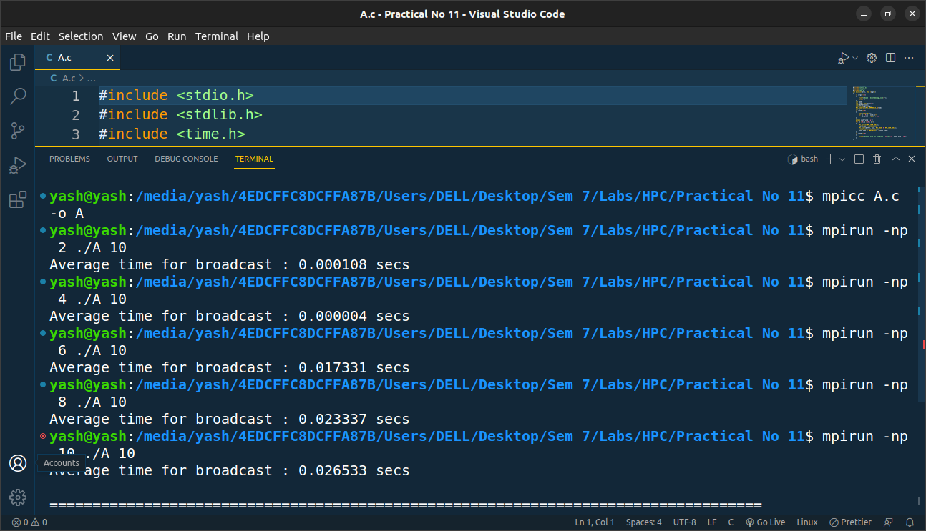

**Screenshot 3:**

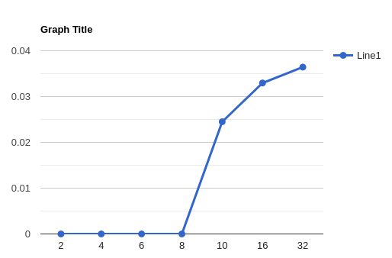

**Problem Statement 2:**

Repeat problem 2 above with varying message sizes for reduction (Program B).Explain the observed performance of the reduction operation.

**Screenshot 4:**

#include<stdio.h>

#include<stdlib.h>

#include<time.h>

#include<mpi.h>

intmain(intargc,char*argv*[]*)

{

    if(argc!=2)

    {

        printf("Usage : reduce message_size\n");

        return1;

    }

    int rank;

    int size =atoi(argv[1]);

    charinput_buffer[size];

    charoutput_buffer[size];

    MPI_Init(&argc,&argv);

    MPI_Comm_rank(MPI_COMM_WORLD,&rank);

    int i;

    srand(time(NULL));

    for(i =0; i < size; i++)

        input_buffer[i]=rand()%256;

    doubletotal_time=0.0;

    doublestart_time=0.0;

    for(i =0; i <100; i++)

    {

        MPI_Barrier(MPI_COMM_WORLD);

        start_time=MPI_Wtime();

        MPI_Reduce(input_buffer,output_buffer, size, MPI_BYTE, MPI_BOR,0, MPI_COMM_WORLD);

        MPI_Barrier(MPI_COMM_WORLD);

        total_time+=(MPI_Wtime()-start_time);

    }

    if(rank ==0)

    {

        printf("Average time for reduce : %fsecs\n",total_time/100);

    }

}

**Screenshot 5:**

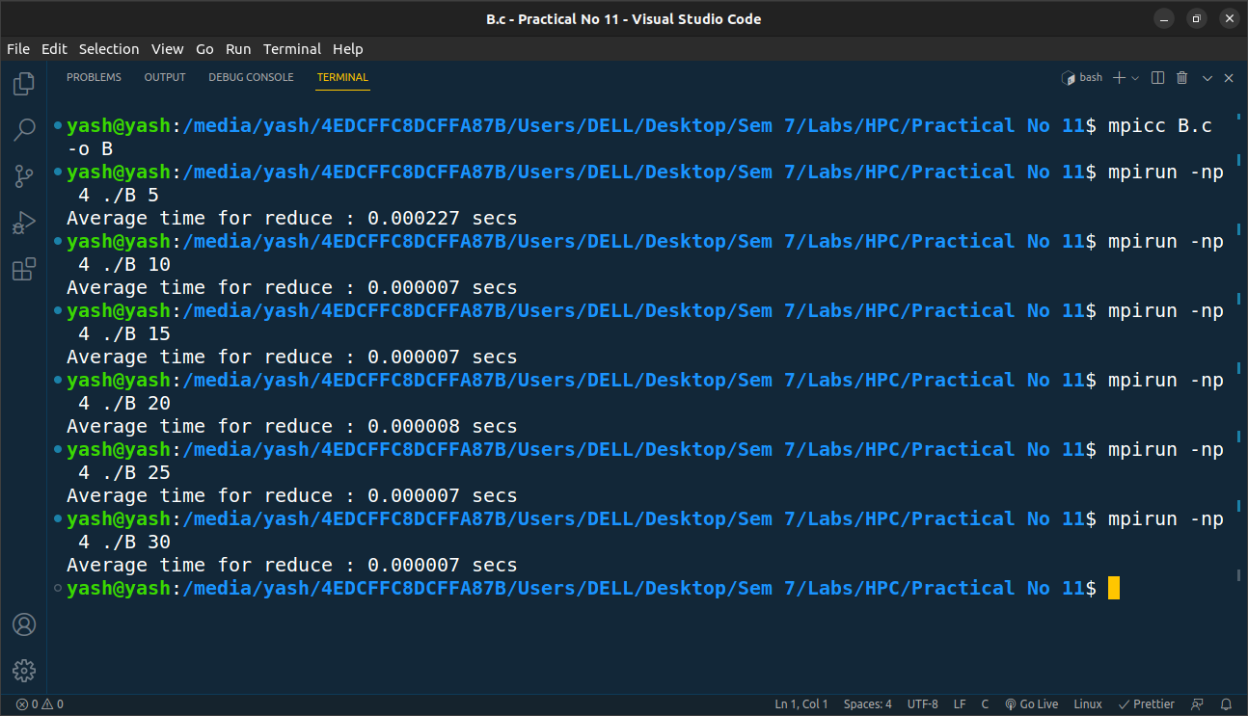

**Screenshot 6:**

